Section One: Short response 30% (54 marks)
Question 1
The table below shows some data for two planets orbiting a distant star in another galaxy.
Planets | Mass (kg) | Orbital radius (m) | Radius of planet (m) | Length of one day (s) | Orbital period (s)
Alpha | 1.15 x 10²⁵ | 4.50 x 10¹¹ | 7.9 x 10⁶ | 9.6 x 10⁴ | 8.50 x 10⁷
Beta | 1.60 x 10²⁴ | 9.00 x 10¹¹ | 3.8 x 10⁶ | 4.8 x 10⁴ | -
Calculate the value for the orbital period of Beta using the appropriate data in the table.
(5 marks)
Required Data:  $$r_{ALPHA}=4.50 × {10}^{11}m; r_{BETA}=9.00 × {10}^{11}m$$  $$T_{ALPHA}=8.50 × {10}^{7}s; T_{BETA}= ?$$ | 1 mark
According to $r^{3}= \frac{GmT^{2}}{4π^{2}}, {r^{3}}/{T^{2}}=constant$ | 1 mark
$$∴ {{\left(r_{ALPHA}\right)}^{3}}/{{\left(T_{ALPHA}\right)}^{2}}= {{\left(r_{BETA}\right)}^{3}}/{{\left(T_{BETA}\right)}^{2}}$$ | 1 mark
$${{\left(4.50 × {10}^{11}\right)}^{3}}/{{\left(8.50 × {10}^{7}\right)}^{2}}= {{\left(9.00 × {10}^{11}\right)}^{3}}/{{\left(T_{BETA}\right)}^{2}}$$ | 1 mark
$$∴ T_{BETA}=2.40 × {10}^{8}s$$ | 1 mark

Question 2
A student conducted an experiment to illustrate Lenz’s Law by dropping identical bar magnets (North at the bottom) through three different hollow tubes. All the tubes were of the same length (1.00 m) and thickness (0.50 cm); however, they were made of three different materials: aluminium; copper; and PVC plastic.
The diagram below right illustrates the experiment.
DIAGRAM NOT TO SCALE
Bar magnet
Wall thickness (0.50 cm)

Hollow tube (1.00m length)
Hollow tube

The student knew that PVC plastic is an excellent insulator. They also found that the electrical conductivity (σ) (measured in Siemens per metre (Sm⁻¹)) for aluminium is 3.766 x 10⁷ Sm⁻¹; and for copper it is 5.977 x 10⁷ Sm⁻¹. They knew that the higher ‘σ’ for a material, the better the conductor.
In terms of the time it takes for the magnets to fall through each tube, rank them (aluminium, coper, PVC plastic) from fastest to slowest. Place your answers in the table below.

Fastest | PVC Plastic tube
Second fastest | Aluminum tube
Slowest | Copper tube
All in correct order | 3 marks
Only one material in correct place | 1 mark

(3 marks)
Question 3
A uniform concrete block is 1.70 m tall, 0.80 m wide and 0.90 m deep; it has a mass of 900 kg. A minimum horizontal force of 3500 N is required to start sliding the block across the ground.
Friction
1.70 m
3500 N
0.40 m

h = ?

P

900 x 9.80
= 8820 N

- Calculate the maximum height ‘h’ at which the 3500 N horizontal force could be applied without tipping the block over.
(3 marks)
When block starts to tip over, ΣM_{C} = ΣM_{A} around ‘P’. | 1 mark
3500 x h = 900 x 9.80 x 0.4 | 1 mark
$∴$ h = 1.01 m | 1 mark

- If the ground became more slippery due to rain falling on it, does the block become harder or easier to tip over. Explain briefly.
(2 marks)
Harder to tip over. | 1 mark
Lower F_{FRICTION} means that it is harder to exceed the M_{C} due to the weight of the block and start rotation. | 1 mark

Question 4
The graph below shows how the induced EMF in a rotating coil varies over time in a small AC generator. The time (t) axis is measured in seconds (s); the vertical EMF axis is measured in Volts (V).
EMF (V)
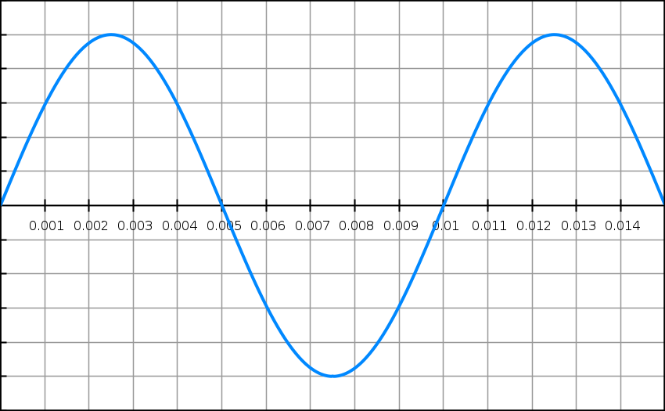
t (s)
-5
-5
5
The generator consists of one coil of 20 turns, with dimensions of 10 cm x 10 cm.
Use this data, the graph and an appropriate formula to determine the strength of the magnetic field (B) in this generator. Show all working.
(5 marks)
From graph, V_{peak} = 5 V | 1 mark
From graph, T = 0.01 s;  $∴f= 1/T= 1/{0.01}=100 Hz$ | 1 mark
A = 0.1 x 0.1 = 0.0100 m² | 1 mark
V_{peak} = 2πNBAf  5 = 2π x 20 x B x 0.01 x 100 | 1 mark
B = 3.98 x 10⁻² T | 1 mark
Question 5
Some students carried out an experiment to investigate the forces required to move an object up a plane. Their equipment was arranged as follows:
Force probe
Pulley
Object
θ

The object has a mass of 1.50 kg; the plane’s angle of incline (θ) is set at 25⁰. The students either held the object at rest or moved it along the plane by pulling or releasing the force probe.
When the object is at rest on the inclined plane, the static frictional force between them can be considered to be negligible. However, when the object is in motion the dynamic frictional force can be considered to be 10.0 N.
Calculate the force registered on the force probe in each of the following situations (show working):
- The object is at rest.
(2 marks)
F_{PROBE} = mg sinθ = 1.50 x 9.80 x sin 25⁰ | 1 mark
$∴$ F_{PROBE} = 6.21 N | 1 mark

- The object is moving at a constant velocity of 2 ms⁻¹ up the plane’s surface.
(2 marks)
F_{PROBE} = 6.21 + 10.0 | 1 mark
$∴$ F_{PROBE} = 16.2 N | 1 mark

- The object is accelerating at a rate of 2 ms⁻² up the plane’s surface.
(2 marks)
F_{PROBE} = 6.21 + 10.0 + 1.50 x 2.00 | 1 mark
$∴$ F_{PROBE} = 19.2 N | 1 mark

Question 6
The diagram below shows AC voltage being supplied to a small factory. The main transmission lines supply electric power to a step down transformer at 6000 V RMS. The transformer then steps this down to 450 V RMS. The wires connecting the factory to the step down transformer have a combined resistance of 0.050 Ω. A total of 24 kW of electric power is being drawn from the output terminals of the transformer.
Transformer
6000 V RMS
Factory
450 V RMS

Factory supply lines

- Calculate the power loss in the factory supply lines.
(2 marks)
$$I= \frac{P}{V}= \frac{24000}{450}=53.3 A$$ | 1 mark
$$∴ P_{lost}= I^{2}R= {53.3}^{2} ×0.05=1.42 × {10}^{2} W$$ | 1 mark

- Finally, calculate the voltage delivered to the factory.
(2 marks)
$$V_{delivered}= V_{T}- V_{drop}=450-53.3 ×0.05$$ | 1 mark
= 447 V | 1 mark

Question 7
The diagram below shows a crane supporting a “heavy object” as shown. The “moving support” can be moved towards the “vertical support” or away from it.
Cable

Moving support
Counterweight

Heavy object

Vertical support

- Explain the role of the “counterweight” and “cable” in this structure.
(2 marks)

The weight of the ‘heavy object’ and the horizontal part of the crane to the right of the ‘vertical support’ produce clockwise moments on the crane around the ‘vertical support’. | 1 mark
The ‘counterweight’ and the tension in the ‘cable’ provide anticlockwise moments to balance the clockwise moments around the ‘vertical support’ and keep the crane in mechanical equilibrium. | 1 mark

- Explain how the tension in the cable changes if the ‘heavy object” is moved to the right by the “moving support”.
(2 marks)
Moving the ‘heavy object’ increase the clockwise moments on the crane around the ‘vertical support’. | 1 mark
To balance this increased the clockwise moments and maintain mechanical equilibrium, the tension in the cable must increase. | 1 mark

Question 8
The diagram below shows four positions on a rollercoaster track.
A
D

B

C

(a) At which point on the track do the occupants of a rollercoaster on the track experience MAXIMUM normal force? Explain.
(2 marks)
At point ‘C’. | 1 mark
Bottom of vertical circle, N is at a maximum;  $$N= F_{C}+W$$  $$∴ N= \frac{mv^{2}}{r}+mg$$ | 1 mark

(b) The occupants of the rollercoaster feel ‘weightless’ at ‘A’. Derive an expression relating the instantaneous speed ‘v’ of the rollercoaster and the radius of the track ‘r’ at ‘A’ to cause this sensation.
(3 marks)
‘A’ is at the top of a vertical circle; if weightless (N = 0):  $$\frac{mv^{2}}{r}-mg=0$$ | 1 mark
Hence:  $$\frac{mv^{2}}{r}= mg$$ | 1 mark
$$∴v= \sqrt{gr}$$ | 1 mark
Question 9
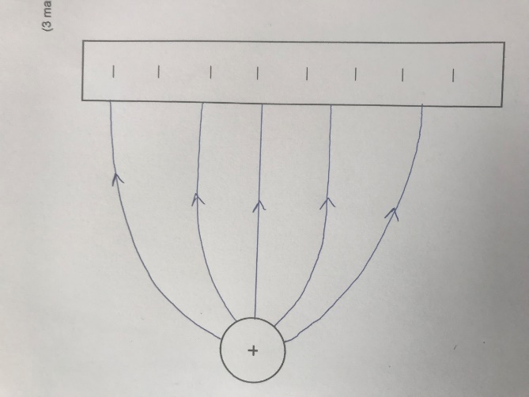
The diagram below shows a positive point charge near a negatively charged plate. Complete the diagram by drawing the resulting electric field created by these charged objects. Include at least 5 field lines.
(3 marks)

At least 5 lines drawn | 1 mark
Direction correct | 1 mark
Shape correct (lines must leave and enter point charge and plate at right angles) | 1 mark

Question 10
A cyclist moves their bicycle by pushing on the pedals of their bicycle. The maximum force the cyclist can exert on one pedal is 150 N. The pedals are both 10 cm from their centre of rotation.
10 cm
Pedal
Pedal

Centre of rotation

- Describe the location of the pedals in relation to the centre of rotation when maximum torque is being exerted by the cyclist.
    - mark)

Maximum Torque occurs when the pedals are in a horizontal position. | 1 mark

- Calculate the maximum torque exerted by the cyclist when the pedals are in this position.
(2 marks)

T_{MAX} = Fr sinθ = 150 x 0.10  (only the pedal being pushed downwards can produce torque) | 1 mark
$∴$ T_{MAX} = 15.0 Nm | 1 mark

- Describe the positons of the pedals when minimum torque is exerted by the cyclist. Explain your answer.
(2 marks)
Pedals are in a vertical position. | 1 mark
$$∴r=0;T=0$$ | 1 mark

Question 11
The diagram below shows the trajectory of a projectile as it travels from left to right (ie – from X to Y to Z.
Y
Z
X

 | At ‘X’ | At ‘Y’ | At ‘Z’
A
B
C
D
E |  | 0
F |  | 0

- Which set of vectors (A – F) best illustrates the acceleration experienced by the ball in flight (ignore air resistance)?
(1 mark)
B | 1 mark
- Which set of vectors (A – F) best illustrates the instantaneous velocity of the ball in flight (ignore air resistance)?
(1 mark)
C | 1 mark
- Which set of vectors best illustrates the vertical component of the ball’s velocity in flight (ignore air resistance)?
(1 mark)
F | 1 mark
- If air resistance is taken into account, which set of vectors best illustrates the force due to this air resistance experienced by the ball in flight?
(1 mark)
A | 1 mark

Question 12
Two current carrying wires are situated 50.0 cm apart. Wire A is carrying a current of 0.500 A in an upwards direction; wire B is carrying a current of 0.375 A. The diagram below shows this situation.
Wire B
Wire A
50.0 cm

x
P

The point P is located between the two wires. The net magnetic field at this point due to the current in the two wires is calculated to be zero.
- Indicate the direction of the current in Wire B.
(1 mark)
Upwards | 1 mark
- Determine the location of point P by calculating distance ‘x’. Show all working.
(4 marks)
$$B_{A}= B_{B}$$ | 1 mark
$$B_{A}= \frac{μ_{o}}{2π} \frac{I}{r}= \frac{μ_{o}}{2π} \frac{0.500}{x}$$  $$B_{B}= \frac{μ_{o}}{2π} \frac{I}{r}= \frac{μ_{o}}{2π} \frac{0.375}{0.50-x}$$ | 1 mark
$$\frac{μ_{o}}{2π} \frac{0.500}{x}= \frac{μ_{o}}{2π} \frac{0.375}{0.50-x}$$ | 1 mark
$$\frac{0.500}{x}= \frac{0.375}{0.50-x}$$  $$0.375x=0.250-0.50x$$  $$0.875x=0.250$$  $$x=0.286 m$$ | 1 mark
End of Section One
Section Two: Problem-solving 50% (90 Marks)
Question 13 (17 marks)

In 1996, a joint experiment between NASA and Italy was conducted to try and produce the world’s first space tether.
In this experiment, a spherical satellite was deployed by the Space Shuttle. The satellite and the Shuttle were connected by a 20 km long conducting tether (wire). In theory, as the Shuttle dragged the satellite and tether through the Earth’s magnetic field, electric power would be produced which could be utilised by the satellite.
The diagram below shows a view of this situation looking down towards the earth. The arrows show the direction of the orbital motion of the satellite, tether and space shuttle. The direction of the earth’s magnetic field at this point in its orbit is shown as downwards.
X X X X X X
TETHER
X X X X X X
X X X X X X
X X X X X X
X X X X X X
X X X X X X
SATELLITE
SHUTTLE

DIRECTION OF MOTION

DIRECTION OF MOTION

- In your own words, explain the electromagnetism principle that was employed in this experiment to generate the electric power.
(2 marks)
Electromagnetic induction. | 1 mark
As charge in the tether cuts across the Earth’s magnetic field flux lines, an EMF is induced. | 1 mark

- On the diagram, draw an arrow to show the direction of the conventional electric current that was generated by the motion of the tether.
(1 mark)
Current is to the right. | 1 mark

- One of the design faults that had to be overcome with this setup was that the electric power generated slowed the shuttle and satellite down.

- Explain why the orbital speed of the Shuttle, tether and satellite would have reduced due to the electric power generated.
(2 marks)
Lenz’s law states that the induced EMF/current in the tether must oppose the change that produced it. | 1 mark
Hence, a magnetic force is created that opposes the motion of the tether, Shuttle and satellite. | 1 mark

- The electric power generated was stored in batteries on the satellite. The stored charge from this battery was used to combat the problem described in part (i); it could even be used to increase the orbital speed of the Shuttle, tether and satellite. Explain how this could occur using electromagnetism concepts. As part of your answer, show on the diagram the direction current would have to flow from the batteries to achieve this.
(3 marks)

X X X X X X
X X X X X X
X X X X X X
X X X X X X
X X X X X X
X X X X X X

Current is to the left. | 1 mark
If the tether carries a current to the left, a magnetic force in the same direction as the motion of the tether, Shuttle and satellite is created. | 1 mark
A force in this direction will result in an increasing velocity for the tether, Shuttle and satellite. | 1 mark

The Shuttle, tether and satellite followed an orbit around the earth with an average altitude 296 km.

- Using data from your Formulae and Constants Sheet, calculate the orbital speed of the Shuttle, tether and satellite around the earth.
(4 marks)
$$m_{EARTH}=5.97 × {10}^{24} kg;r=6.38 × {10}^{6}+296 × {10}^{3}=6.68 × {10}^{6} m$$ | 1 mark
$$F_{c}= F_{G}; {m_{S}v^{2}}/r= {Gm_{E}m_{S}}/{r^{2}}; ∴v= \sqrt{{Gm_{E}}/r}$$ | 1 mark
$$v= \sqrt{{6.67 x {10}^{-11} ×5.97 × {10}^{24}}/{6.68 × {10}^{6}}}$$ | 1 mark
$$v=7.72 × {10}^{3} ms^{-1}$$ | 1 mark

The maximum EMF generated by the tether was about 3500 V.

- As the tether was unfurled to its full length, scientists predicted that the EMF generated would increase in a highly predictable way. Explain.
(2 marks)
Since EMF is directly proportional to ‘l’, | 1 mark
As ‘l’ increases, so will EMF generated (‘B’ and ‘v’ remain constant). | 1 mark

- Use the maximum EMF generated and previous data in this question to calculate the strength of the earth’s magnetic field at this altitude. [If you were unable to calculate the orbital speed in part (d), use a value of 7.50 x 10³ ms⁻¹]
(3 marks)
$${EMF}_{max}=lvB$$ | 1 mark
$$3500=20000 x 7.72 × {10}^{3} ×B$$ | 1 mark
$$∴B=2.27 × {10}^{-5} T$$ | 1 mark
$$If v=7.50 × {10}^{3} ms^{-1} is used, then B= 2.33 × {10}^{-5} T)$$
Question 14 (16 marks)

An archer is challenged to hit an apple with an arrow.
The apple is thrown vertically upwards into the air with a velocity of 10ms⁻¹. At the same instant, the archer – who is located a horizontal distance of 17.2m from where the apple is launched – fires the arrow at an angle (θ) and speed (v). The apple and arrow are both launched from the same height.
The archer manages to hit the apple 4.00m above its launch height on its downward path.
- Show through calculations that the maximum height attained by the apple is 5.10m.
(3 marks)
$$v^{2}= u^{2} +2as, ∴s= \frac{\left(v^{2}- u^{2}\right)}{2as}$$ | 1 mark
$$∴s= \frac{\left(0- {10}^{2}\right)}{2 × -9.8}$$ | 1 mark
$$s=5.10m$$ | 1 mark

- In the space below, draw a diagram showing the paths taken by the arrow and the apple from launch until impact. Also include any relevant distances to indicate scale.
(3 marks)
5.10m
4.00m
17.2m

Parabolic path for arrow; up and down path for apple. | 1 mark
Horizontal distances (17.2m) shown. | 1 mark
Vertical distances (4.00m and 5.10m) shown. | 1 mark

- Calculate the time taken for the arrow to hit the apple.
(4 marks)
$$s=ut + 1/2at^{2}; ∴4.00=10t-4.9t^{2}$$ | 1 mark
$$4.9t^{2}-10t +4=0$$ | 1 mark
$$t= \frac{10 ± \sqrt{100-4×4.9×4}}{9.8}$$ | 1 mark
$$t=1.49s$$ | 1 mark

- Hence, calculate the horizontal component of the arrow’s launch velocity. [If you were unable to calculate an answer for part (c), use a time of 1.30s]
(2 marks)
$$v= \frac{s}{t}= \frac{17.2}{1.49}$$ | 1 mark
$$∴ v_{h}=11.5 ms^{-1}$$ | 1 mark

- Finally, using the information you have calculated earlier in this question, determine the initial launch velocity of the arrow. Show all working. Include a vector diagram in your answer. [If you were unable to calculate an answer for part (d), use a horizontal velocity of 11.0ms⁻¹]
(4 marks)
θ
11.0 ms⁻¹
10.0 ms⁻¹

v

Vector diagram correct, all quantities labelled. | 1 mark
Magnitude calculated to 15.2ms⁻¹.  $$v^{2}= {10}^{2} + {11.5}^{2}; ∴v=15.2 ms^{-1}$$ | 1 mark
Angle ‘θ’ calculated to 41.0⁰  $$\tan{θ= \frac{10}{11.5}, ∴ θ=41.0°}$$ | 1 mark
Answer given as a final statement giving reference to the horizontal (or vertical). | 1 mark

Question 15 (15 marks)

The graph below shows how the torque on one (1) coil in an experimental DC motor varies over time.
Torque (Nm)
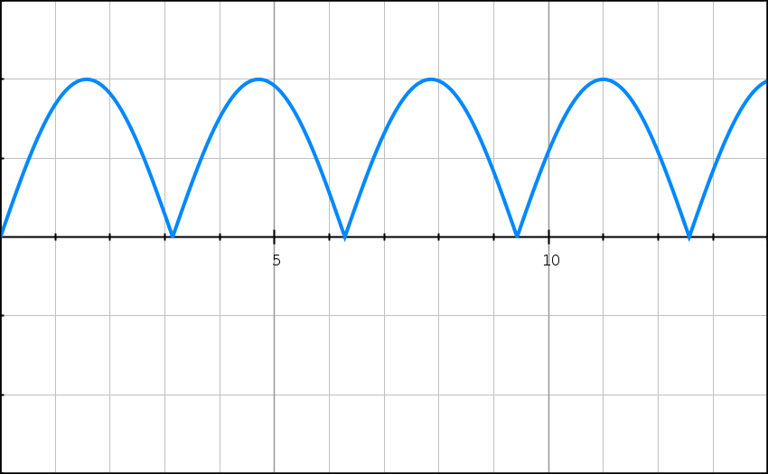
Y
X
Time (ms)
-0.10
-0.05
0.10
0.05

- On the graph, mark one (1) point where:

- the coil would be parallel to the magnetic field. Label this point ‘X’.
(1 mark)
‘X’ should be located at points of MAXIMUM torque. | 1 mark
- the coil would be perpendicular to the magnetic field. Label this point ‘Y’.
(1 mark)
See graph for an example – ‘Y’ should be locate at points of ZERO torque. | 1 mark
- Briefly explain your answer to part (i). A simple diagram should be included in your explanation.
(2 marks)

When the coil is parallel to the magnetic field, the angle between the applied magnetic force and the lever arm ‘r’ (θ) is 90⁰. | 1 mark
Given that T = Fr sinθ, the torque experienced by the coil in this position will be at a maximum (sin 90⁰ = 1.00). | 1 mark

- The shape of this graph suggests the presence of a commutator. Explain.
(2 marks)
The commutator is designed to reverse the direction of the current in the coil every half-turn. | 1 mark
This ensures that the direction of the torque experienced by the coil is in one direction only and is illustrated by the graph only having a positive torque. | 1 mark

Some specifications for the coil and the DC motor are shown below:

Current in coil (I) = 0.500 A
Dimensions of coil (square shape): 20 cm x 20 cm
Number of turns (n) = 20

- Using appropriate formulae from your Formulae and Constants Sheet, show that the maximum torque (T_{MAX}) generated by the coil can be derived by the following expression:

$$τ_{max}=IBAn$$

Where ‘B’ is equal to the magnetic field strength in the DC motor.
(3 marks)
$$τ_{MAX}=2 ×Fr=2 x IBln x r$$ | 1 mark
$$=2 × IBn ×l × w/2$$ | 1 mark
$$=IBn ×lw=IBnA$$ | 1 mark

- Using the expression in part (c), the graph at the beginning of this question, and the specifications of the DC motor, calculate the magnetic field strength B in the DC motor.
(3 marks)
$$τ_{MAX}=0.10 Nm (from graph)$$ | 1 mark
$$0.10=0.500 ×B ×0.20 ×0.20 ×20$$ | 1 mark
$$∴B=0.250 T$$ | 1 mark

- If the DC motor ‘jams’ and stops rotating, it has designed safeguards to prevent it from overheating and ‘burning out’. Without describing these safeguards, explain why they are necessary in this particular situation.
(3 marks)
The normal movement of a rotating coil induces a back emf, or emf with opposite polarity to the supply. | 1 mark
In the absence of the back emf, a stationary coil will experience a much higher net emf. | 1 mark
Hence, the current in the coil will increase beyond the specifications of the circuit. | 1 mark

Question 16 (16 marks)
A 60.0 kg person is standing on the end of a uniform 5.00 m long viewing platform with a mass of 500 kg. The platform is horizontal and extends out from the side of a cliff face. It is supported by a steel beam that extends from the side of the cliff face to the end of the platform. The platform is shown below. ‘P’ is the point of contact between the viewing platform and the cliff face.
Cliff face
Viewing Platform
60⁰
P

Steel Beam

- In the space below, draw a free body diagram showing all of the forces acting on the viewing platform with the 60.0 kg person standing in the position stated at the beginning of the question. Label the forces appropriately.
(3 marks)
F (beam)  F (P)  W (platform)  W (person) | W (platform) and W (person) = 1 mark  F (P) = 1 mark  F (beam) = 1 mark

- Show, with a calculation, that the size of the force exerted by the steel beam is approximately 6.1 x 10³ N.
(5 marks)
Take moments about ‘P’, ΣM_{C} = ΣM_{A}
W (person) = 60 x 9.8 = 588 N  W (platform) = 500 x 9.8 = 4900 N | 1 mark
4900 x 2.5 + 588 x 5 = F x 5 x sin 30⁰ | 2 marks
F = ¹⁵¹⁹⁰/_{2.50} | 1 mark
F = 6.08 x 10³ N | 1 mark
- Hence, calculate the magnitude of the force exerted by ‘P’ (ie – the cliff face) on the viewing platform. You may need to alter your answer to part (a) as a result of this calculation.
(5 marks)
6.08 x 10³ x sin 30⁰ = 3.04 x 10³ N  6.08 x 10³ N  6.08 x 10³ x cos 30⁰ = 5.27 x 10³ N  30⁰ | 2 marks
$$ΣF_{UP}= ΣF_{DOWN;} ∴ F_{P}=4900+588-3040$$  2.45 x 10³ N N  5.27 x 10³ N  F_{P}  $$F_{p}=2.45 ×{10}^{3} N up$$ | 1 mark
$$F_{P}=5.27 × {10}^{3} N left$$ | 1 mark
$${F_{P}}^{2}= {\left(2.45 ×{10}^{3}\right)}^{2}+ {\left(5.27 × {10}^{3}\right)}^{2}; ∴ F_{P}=5.81 × {10}^{3} N$$ | 1 mark

- The person now walks towards the cliff face. In your own words, describe how the force exerted by the beam would change as this occurred. Explain your answer.
    - marks)
As the person moves towards the cliff face, the size of their moment will decrease (because ‘r’ decreases). | 1 mark
Hence, size of the moment provided by the beam will decrease to maintain equilibrium. | 1 mark
Therefore, the size of the force exerted by the beam will decrease. | 1 mark

Question 17 (17 marks)

The diagram below shows the primary coil and secondary coil in a stepdown transformer. They are both wrapped around a ring made of iron.

Secondary coil
12 V AC RMS 50 Hz
??? W
??? turns
Primary coil
240 V AC RMS 50 Hz
10 000 W
1000 turns

Iron core

- Use the data above to determine the number of turns in the secondary coil. Show all working.
(2 marks)
$$\frac{V_{P}}{V_{S}}= \frac{N_{P}}{N_{S}}; \frac{240}{12}= \frac{1000}{N_{S}}$$ | 1 mark
$$∴ N_{S}=50.0 turns$$ | 1 mark

- Now assume the transformer is NOT ‘ideal’ and its ‘efficiency’ is measured to be 90%. Given this, calculate the power generated in the transformer’s secondary coil.
(2 marks)
$$P_{S}=0.90 × P_{P}=0.90 ×10000$$ | 1 mark
$$∴ P_{S}=9000 W$$ | 1 mark

- The power losses that reduce the efficiency of the transformer originate in the COILS and the IRON CORE RING. These losses can be reduced through careful design of the transformer. For each of the COILS and IRON CORE RING, describe one (1) modification that is made and how it reduces the power losses. Refer specifically to the transformer at the start of this question.
(4 marks)
- COILS
In this transformer, the secondary coil carries the higher current. | 1 mark
The secondary coil would be made of thicker wire to reduce resistance and therefore heat losses. | 1 mark

- IRON CORE RING
The iron core will have eddy currents induced in them due to the changing magnetic field. | 1 mark
To reduce the size of these eddy currents the iron core is laminated. | 1 mark

- The graph below shows how the emf varies over time in the primary coil. On the same set of axes, draw the corresponding graph of emf v time graph for the secondary coil. When drawing this graph, consider the following:

- What is the shape of this graph?
- What is V_{PEAK} for the secondary coil? (You may wish to show a calculation in the space below)
- What is the period (T) for this emf v time graph?
- When would V_{PEAK} occur in the secondary coil?
(3 marks)
EMF in Secondary Coil (V)
time (s)
17.0
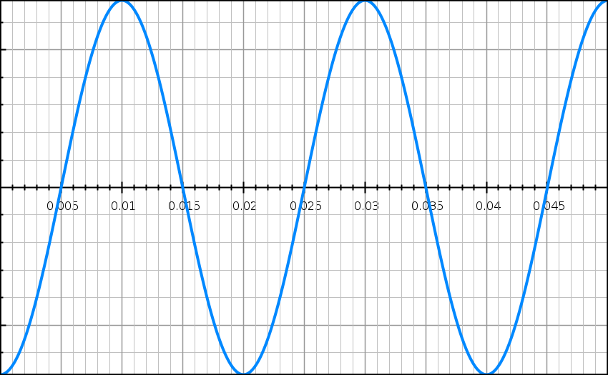
-17.0

$$Secondary Coil; V_{peak}= \sqrt{2} x 12.0=17.0 V$$ | 1 mark
Shape of graph – sinusoidal, sine wave | 1 mark
Period of graph, T = 0.02 s | 1 mark
- Step-up transformers are generally found at the start of our transmission system (eg – at the power station itself where electric power is generated). Explain why it is necessary to ‘step up’ transmission voltage early in the transmission process.
(3 marks)
There are power losses due to heat in the power lines (P_{LOST} = I²R). | 1 mark
Power is transmitted at a constant rate: P_{T} = V_{T}I_{T}. | 1 mark
Hence, if transmission voltage (V_{T}) is increased, transmission current (I_{T}) is decreased and power loss is reduced. | 1 mark

- If the EMF in the primary coil were to remain constant, describe in words the effect this would have on the EMF in the secondary coil. Explain your answer.
(3 marks)
The EMF in the primary coil (and, hence the current) is constant. | 1 mark
Hence, the magnetic field due to the primary coil passing through the secondary coil is also constant. | 1 mark
Therefore, the change in flux through the secondary coil is zero; induced EMF = 0. | 1 mark
Question 18 (10 marks)
A small object of mass 50.0 g is being rotated freely in a vertical circle of radius 1.50 m. It is attached to a string of the same length. At the position shown (ie – the top of the vertical circle), the tension in the string is momentarily equal to zero. The string is able to withstand a maximum tension of 2.50 N before it snaps.
object
Direction of motion
v = 1.00 ms⁻¹

r = 1.50 m

X

Y
Which of the arrows below best describes the direction of the object’s motion at point ‘X’?
(1 mark)
A
B
C
D
C | 1 mark

- Show via calculation that the object is travelling with a speed 3.83 ms⁻¹ when it is at the top of the vertical circle.
(3 marks)
$$At top, N= \frac{mv^{2}}{r}-mg; N=0; ∴v= \sqrt{gr}$$ | 1 mark
$$∴v= \sqrt{9.80 ×1.50}$$ | 1 mark
$$v=3.83 ms^{-1}$$ | 1 mark

- Given that the object is rotating freely under the influence of gravity, calculate what its speed would be if it reached the bottom of the circle at point ‘Y’.
(3 marks)
$$E_{TOTAL}=0.5×0.050×{3.83}^{2}+0.050×9.80×3=1.84 J$$ | 1 mark
$$At{{}_{}^{'}Y}^{'}, 1.84=0.5×0.050×v^{2}$$  $$∴v= \sqrt{\frac{2 x 1.84}{0.050}}$$ | 1 mark
$$∴v=8.57 ms^{-1}$$ | 1 mark

- Hence determine whether the string would snap before the object reaches Y’. Support your answer with a calculation.
[If you were unable to calculate an answer for part (c), use a value of 8.60 ms⁻¹]
(3 marks)
$$At{{}_{}^{'}Y}^{'}, N= F_{C}+W= \frac{mv^{2}}{r}+mg$$ | 1 mark
$$∴N= \frac{0.050 × {8.57}^{2}}{1.50}+0.050 ×9.80=2.94 N$$ | 1 mark
2.94 N > 2.50 N. Hence, the string will snap. | 1 mark

End of Section 2
Section Three: Comprehension and Data Analysis 20% (36 Marks)
Question 19 (18 marks)
A group of students conducted an investigation to calculate an experimental value for ‘μ₀’ – the magnetic constant. They had the following equation from their Formulae and Constants Sheet at their disposal:
$$B= \frac{μ_{0}}{2π} \frac{I}{r}$$

Where μ₀ = the magnetic constant; I = current in the conductor; r = distance from the conductor.
They also had the following equipment at their disposal:
1 x power pack; 1 x ammeter; 1 x 50cm length of straight conductor; 1 x rheostat; 1 x switch; 2 x wooden stands; 4 x wooden blocks; 1 x orienteering compass; 1 x ruler; enough connecting wires and alligator clips as required.
The horizontal straight conductor is connected into a circuit that allows the current flowing through it to be controlled. This current is set at a constant value of 5.00 A.
The horizontal straight conductor is aligned in a North-South direction using the compass. It is elevated 40 cm above the bench by the wooden stands.
The compass is set on wooden blocks directly beneath the straight conductor. The distance the compass is below the straight conductor ‘r’ can be varied.
The earth’s magnetic field strength (B_{E}) is known to be equal to 5.00 x 10⁻⁵ T and can be considered to be horizontal in this part of the laboratory.
The diagrams below offer some more information about this set up.
SIDE VIEW
Straight conducting wire

r
Compass
Wooden stand
Wooden stand
Wooden blocks

TOP VIEW
Compass
Straight conductor aligned in a North-South direction
NORTH

When the current in the straight conductor is turned on, the compass needle deviates through an angle ‘θ’. This deviation is due to the magnetic field produced by the current-carrying conductor (B_{I}). With this orientation of the straight conductor, ‘B_{E}’ and ‘B_{I}’ are both perpendicular to each other. Their relationship with ‘θ’ is shown below:
B_{I}
$$\frac{B_{I}}{B_{E}}= \tan{θ}$$
$$∴ B_{I}= B_{E} \tan{θ}=5.00 × {10}^{-5} \tan{θ}$$
θ
B_{E}

Using the above concept, the students were able to calculate experimental values for ‘B_{I}’ at different distances ‘r’ from the wire. They collected two values for ‘θ’ at each distance ‘r’ by reversing the current for each trial. The values they collected are displayed in the table below:
r (m) | θ_{left} | θ_{right} | θ_{average} | tan θ | B_{I} (x 10⁻⁵ T) | ¹/r (m⁻¹)
0.050 | 21.5⁰ | 22.1⁰ | 21.8⁰ | 0.400 | $$2.00$$ | 2.0 x 10¹
0.10 | 10.7⁰ | 11.9⁰ | 11.3⁰ | 0.200 | 1.00 | 1.0 x 10¹
0.15 | 6.5⁰ | 8.7⁰ | 7.6⁰ | 0.134 | 0.67 | $$6.67$$
0.20 |  | 6.2⁰ | 5.7⁰ | 0.100 | 0.50 | 5.0
0.25 | 4.3⁰ | 4.7⁰ | 4.5⁰ | 0.080 | 0.40 | 4.0
0.30 | 3.4⁰ | 4.0⁰ | 3.7⁰ | 0.066 | 0.33 | 3.3

- On the diagram below, draw an arrow on the straight conductor to show the direction of conventional current that would have produced the deflection shown on the compass.
(1 mark)
TOP VIEW
Compass
Straight conductor aligned in a North-South direction
NORTH

Conventional current – downwards arrow on conductor. | 1 mark

- Explain why the students collected two different values of ‘θ’ (θ_{left} and θ_{right}). As part of your answer, also explain why wooden stands are used to elevate the straight conductor instead of steel retort stands.
(3 marks)
The direction of the Earth’s magnetic field can be distorted locally by the presence of ferromagnetic materials. | 1 mark
Wooden stands are not made of ferromagnetic materials. | 1 mark
Deflections left and right are collected to try and control the variable of this distortion of the earth’s magnetic field by ferromagnetic materials. | 1 mark

- The table is incomplete. Calculate values for these missing quantities and write them in the table. Show your working in the space below. Round to the correct number of significant figures.
(3 marks)
$$r=0.05 m; B_{I}=5 × {10}^{-5} × \tan{21.8°}=2.00 × {10}^{-5}T$$ | 1 mark
$$r=0.15 m; \frac{1}{r}= \frac{1}{0.15}=6.67 m^{-1}$$ | 1 mark
$$r=0.20 m; θ_{average}= \frac{θ_{left} + θ_{right}}{2}; ∴5.7= \frac{θ_{left}+6.2}{2} ; ∴ θ_{left}=5.2°$$ | 1 mark

- On the grid on the next page, plot a graph of ‘B_{I}’ against ‘¹/r’ (place ‘B_{I}’ values on the vertical axis). Draw a line of best fit for your data.
(4 marks)
- Calculate the gradient of the line of best fit. Show working below. Include units.
(4 marks)
Uses points of the line of best fit; eg – $\left(2.00 × {10}^{-5}, 19.9\right) and \left(0.3 × {10}^{5}, 3\right)$ | 1 mark
$$Slope= \frac{2.00 × {10}^{-5}-0.3 × {10}^{-5}}{19.9-3}$$ | 1 mark
$=1.01 × {10}^{-6}$  (accept between 0.80 x 10⁻⁵ and 1.20 x 10⁻⁵) | 1 mark
Tm (units) | 1 mark

- Use your answer from part (e) to calculate an experimental value for the magnetic constant ‘μ₀’. Show your working.
(3 marks)
$$B= \frac{μ_{0}}{2π} \frac{I}{r}; slope= B/{1/r}=Br$$ | 1 mark
$$∴slope= \frac{μ_{0}}{2π} . I; μ_{0}= \frac{slope ×2π}{I}$$ | 1 mark
$∴ μ_{0}= \frac{1.01 × {10}^{-6 } ×2π}{5}=1.26 × {10}^{-6}$  (accept between 1.01 x 10⁻⁵ and 1.51 x 10⁻⁵) | 1 mark
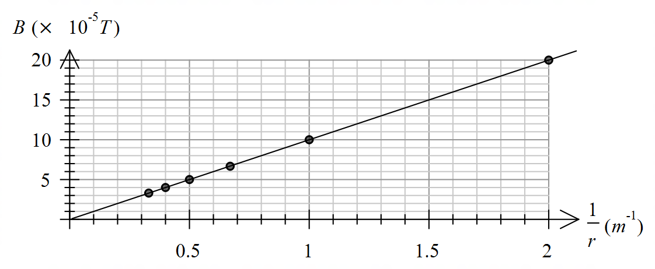

B_{I} on the vertical (y) axis. | 1 mark
Correct units supplied. | 1 mark
Points correctly plotted. | 1 mark
Line of best fit correctly drawn. | 1 mark

Question 20 (18 marks)
“Cassini Mission to Saturn”
- Describe how Cassini was able to increase its speed relative to the Sun by using “gravity-assist swing-by’s” around planets like Venus and the Earth. Use a diagram as part of your answer.
(3 marks)
Cassini used the motion of the planet to ‘pull’ on it in the direction of its motion to increase its speed. | 1 mark
Diagram – planet and its direction of motion indicated. | 1 mark
Diagram – motion of spacecraft indicated. | 1 mark

Path of planet
Path of Cassini

- The rings of Saturn consist of “countless unconnected particles, ranging in size from nearly invisible dust to icebergs the size of a house.” In a particularly thin ring, the orbital speed of each these vastly different masses would be the same. Using relevant formulae, explain.
(3 marks)
‘Objects’ in the ‘same ring’ have the same orbital radius ‘r’. | 1 mark
$$v= \sqrt{{Gm}/r or mentions Kepler^{'}s3rd Law;period \left(T\right)is independent of mass.}$$ | 1 mark
Hence, the orbital speed ‘v’ of a satellite depends on the orbital radius ‘r’; and the mass of the central body ‘m’ (in this case, mass of Saturn). ‘v’ is independent of the mass of the satellite. | 1 mark

- Cassini’s orbit around Saturn is at an altitude of only one-sixth the diameter of Saturn itself. Saturn’s diameter is 116 464km; and its mass is 5.68 x 10²⁶ kg.

- Calculate the radius of Cassini’s orbit around Saturn (in metres).
(2 marks)

$$r= \frac{116464 × {10}^{3}}{2}+ \frac{116464 × {10}^{3}}{6}$$ | 1 mark
$$∴r=7.76 × {10}^{7} m$$ | 1 mark

- Hence, calculate the orbital speed of Cassini at this altitude. Show working.
(3 marks)

$$F_{c}= F_{g}; \frac{m_{C}v^{2}}{r}= \frac{GM_{S}m_{C}}{r^{2}}; ∴v= \sqrt{\frac{GM_{S}}{r}}$$ | 1 mark
$$v= \sqrt{\frac{6.67 × {10}^{-11} ×5.68 × {10}^{26}}{7.76 × {10}^{7}}}$$ | 1 mark
$$=2.21 × {10}^{4} ms^{-1}$$ | 1 mark

- A quote from paragraph 6 states that: “Gravity at the top of Saturn’s clouds is similar to the gravity near the surface of Earth.”

- The data in part (c) illustrates how much bigger in volume Saturn is compared to the earth. Hence, explain how gravity at the top of Saturn’s clouds could be similar to the gravity near the surface of Earth.
(3 marks)
Gravitational field strength: $g= {Gm}/{r^{2}}$ | 1 mark
r (Saturn) > r (Earth). | 1 mark
density (Saturn) < density (Earth). | 1 mark

(ii) Hence, using data provided in part (c), calculate an estimate for the height of the clouds above Saturn’s surface.
(4 marks)
$$g_{E} \left(surface\right)=9.80 ms^{-2}; ∴ g_{S}=9.80 ms^{-2}$$ | 1 mark
$$9.80= \frac{GM_{S}}{r^{2}}; ∴r= \sqrt{\frac{GM_{S}}{9.8}}$$ | 1 mark
$$r= \sqrt{\frac{6.67 × {10}^{-11} ×5.68 × {10}^{26}}{9.80}} =6.22 × {10}^{7} m$$ | 1 mark
$$∴h=6.22 × {10}^{7}- \frac{116464 × {10}^{3}}{2}=3.94 × {10}^{6} m$$ | 1 mark

